Exercise 1: Mocking and Stubbing

Scenario: You need to test a service that depends on an external API. Use Mockito to mock the external API and stub its methods.

Steps:

1. Create a mock object for the external API.

2. Stub the methods to return predefined values.

3. Write a test case that uses the mock object.

**Solutions:**

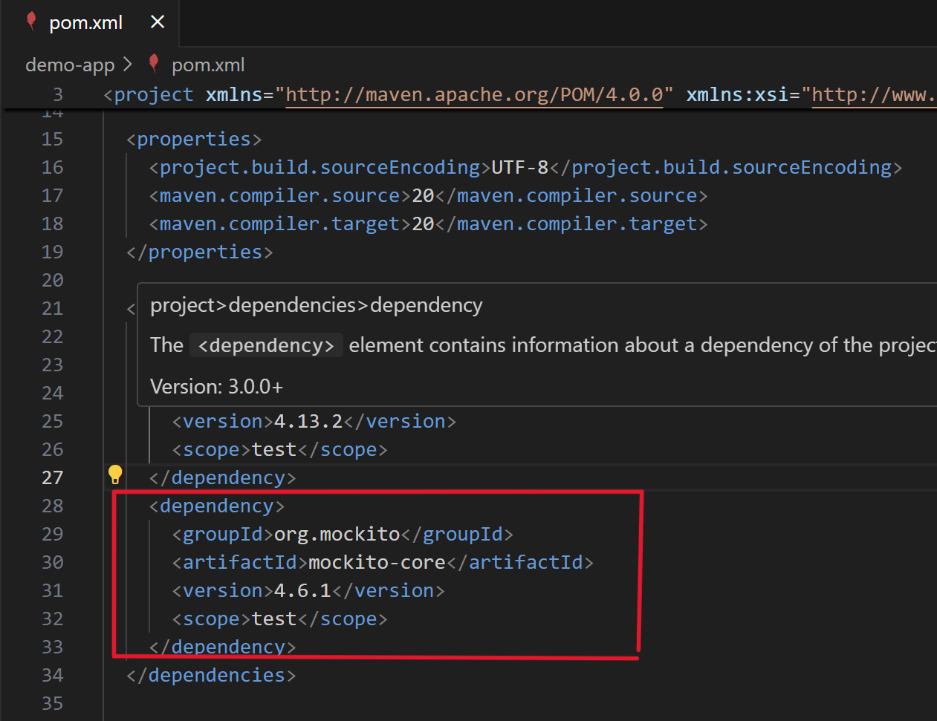step 1. **Adding Mockito** to your **pom.xml**

**step 2.** Creating **ExternalApi interface** via file in main folder naming **ExternalApi.java**

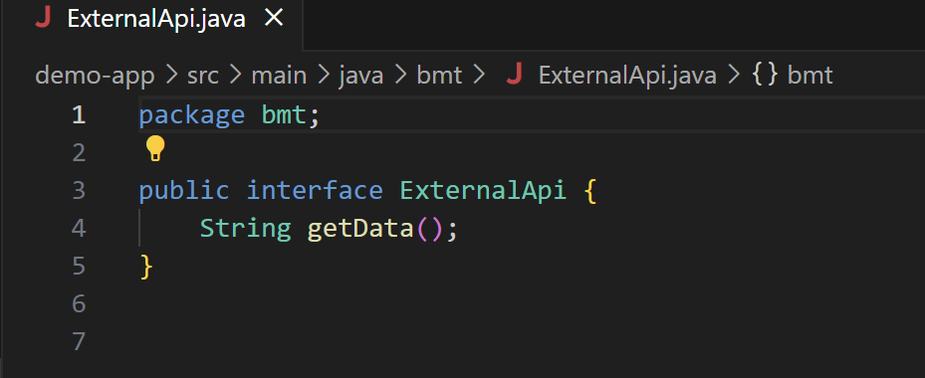

Step **3**. Create **MyService** **class** that uses ExternalApi file in the same directory:

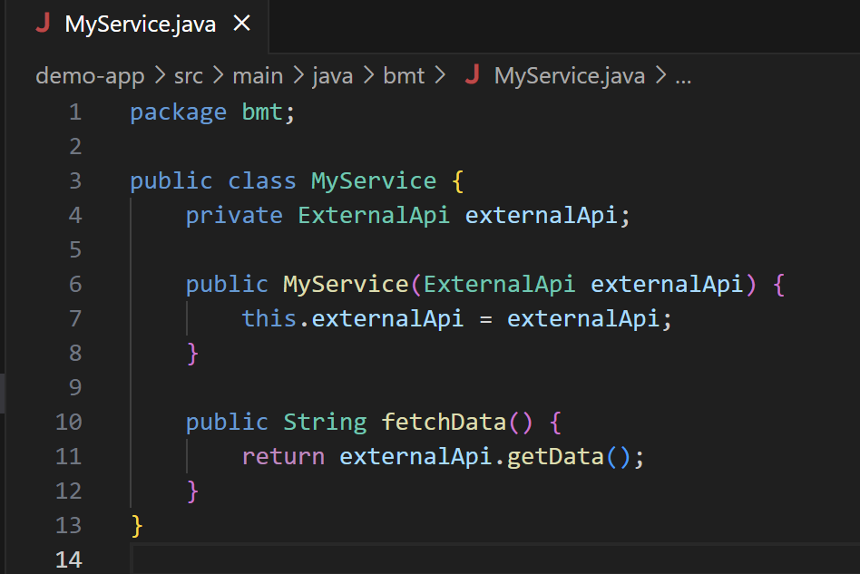

Step **4**. Create **MyServiceTest** file using **Mockito** in test folder & **Run** your **tests** by clicking run-test button or

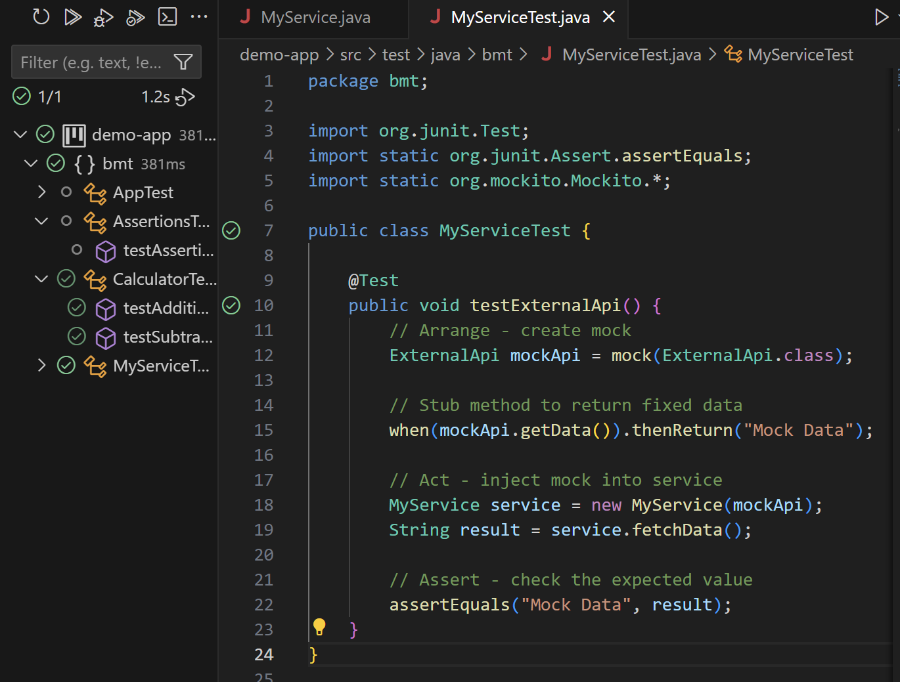 typing ***mvn test*** in the terminal of vs-code:

▪ Here the ***green-tick*** represent the ***successful run of test-cases(1/1) using Mockito dependency***.

***********************************************************************************************